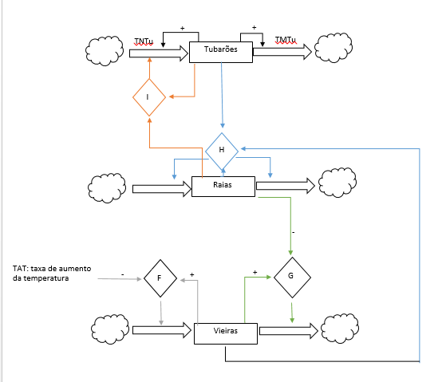

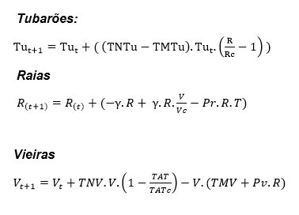

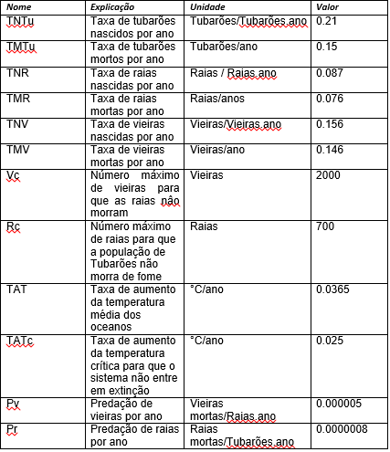

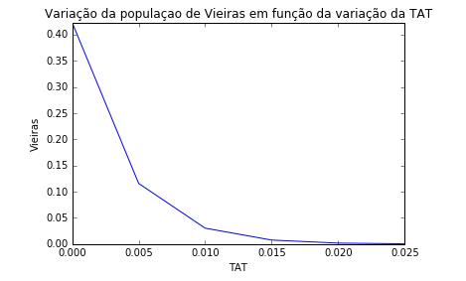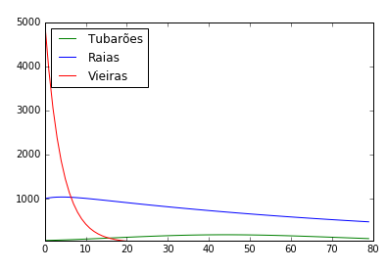

Fontes:

<http://www.nature.com/articles/srep20970> <https://www.researchgate.net/publication/222243583_Differential_predation_and_growth_rates_of_bay_scallops_within_a_seagrass_habitat> <https://archive.org/stream/journalofshellfi170405nati/journalofshellfi170405nati_djvu.txt> <http://spo.nmfs.noaa.gov/mfr703-4/mfr703-42.pdf> <http://www.chesapeakebay.net/channel_files/17827/wilberg_et_al._2011_-_overfishing,_disease,_habitat_loss,_and_potential_extirpation_of_oysters_in_upper_chesapeake_bay.pdf> <http://www.nature.com/article-assets/npg/srep/2016/160215/srep20970/extref/srep20970-s1.pdf> <http://science.sciencemag.org/content/315/5820/1846.full-text.pdf+html> <http://science.sciencemag.org/content/sci/315/5820/1846.full.pdf> <http://courses.washington.edu/mb351/shark%20references/stevens%20et%20al%202000%20chondrichthyan%20fisheries.pdf> <http://voices.nationalgeographic.com/2013/03/01/100-million-sharks-killed-every-year-study-shows-on-eve-of-international-conference-on-shark-protection/> <http://www.pifsc.noaa.gov/library/pubs/tech/NOAA_Tech_Memo_PIFSC_32.pdf> <http://journals.plos.org/plosone/article?id=10.1371/journal.pone.0025028#s1>

Martim Ferreira José

Lucas Fontenla

Victor Hugo